**1 CHAPTER ONE: INTRODUCTION**

* 1. **Background**

Software is a general term for the various kinds of programs used to operate computers and relative devices.

An application is a computer program designed to perform a group of coordinated functions, tasks, or activities for the benefit of the user Examples of an application include a word processor, a spreadsheet, an accounting application, a web browser, a media player, an aeronautical flight simulator, a console game or a photo editor Applications may be bundled with the computer and its system software or published separately, and may be coded as proprietary, open-source or university projects Apps built for mobile platforms are called mobile apps.

A mobile application is a software application developed specifically for use on small, wireless computing devices, such as smart phones and tablets, rather than desktop or laptop computers.

“tabeeb online” is a mobile application that intends to provide a free and easy medical consultation for owners of android operating system mobile phones in a fast secure and private way .

Tabeeb online is beneficial for all its users whether it is a patient by shortening the time spent waiting at the hospital or doctors clinic or a doctor to get a good rate in order to have a good reputation in the market or for the guest by educating him medically by watching the consultations and their replies .

**1.2 Literature review**

There are a lot of applications that provide medical consultations and services available on the play store to be downloaded such as “doctor on demand” and “insta doctor” but research shows that most of the available applications either provide the user with the doctor’s name location and specialty in areas around the user also provide consultations in a private way so that it only can be viewed by the user or the doctor some applications requires a registration even if the user only wants to see the consultations of other patients and doctors some of them also requires scheduling an appointment before communicating with the doctor “tabeeb online” provides these services with much more available options such as fast response private messages between the patient and the doctor and a public consultations that anyone who downloaded the application can look at as a guest without interaction or registration.

**1.3 Business Model**

**1.3.1 Business Needs**

Patients in general needs a way to get answers to their consultations in a fast and private way because a lot of patients does not have the time or the money to go to the hospitals or clinics havening an application that can provide medical advice and consultations on your mobile phone is much more easier than going to the clinics and wait for your turn to get checked up.

**1.3.2.1 Software Context Diagram**

User

Guest

Doctor

Tabeeb online

Provide information and reply. Provides information and consultation.

View recent consultations.

Stores and retrieves system data .

Database

**1.3.2.2 System Scope**

The application maintains patients private data and consultations in order to provide the patient with a reply to his consultation to shorten the needed time to get checked and to lower the cost of treatment.

Also maintains the personal information about the doctor and replies in order to get a high rate the doctor should provide an accurate and fast reply which will affect his reputation in the market.

Allowing the guest to view previous consultations and replies in order to educate him medically.

The database which is a global database maintains and retrieves data from the application.

**1.3.3 Stakeholder Analysis**

|  |  |
| --- | --- |
| Actor | Responsibilities |
| Patient | 1. Determine the doctor area and specialty. 2. Write the consultation. 3. Submit consultation. |

|  |  |
| --- | --- |
| Actor | Responsibilities |
| Doctor | 1. Check notification. 2. Reply consultation. 3. Submit reply. |

|  |  |
| --- | --- |
| Actor | Responsibilities |
| Guest | 1. View and search previous consultations. |

**1.3.4 System Vision Document**

**1.3.4.1 Objectives**

The object is providing a fast and private medical consultation to those who don’t have the time nor the money to go to hospital throughout a simple application that can be downloaded on mobile devices.

**1.3.4.2 Benefits**

* Patient can save time and money and get a fast and accurate reply to their consultation in an easy way.
* Doctor gets a good reputation in the market based on his rates and medical opinions.
* Guest is medically educated.

**1.3.4.3 Capabilities**

1. The application is easy to use.
2. The application is light on the system and

**1.3.5 Project Management**

**1.3.5.1 Project Iteration and Schedule**

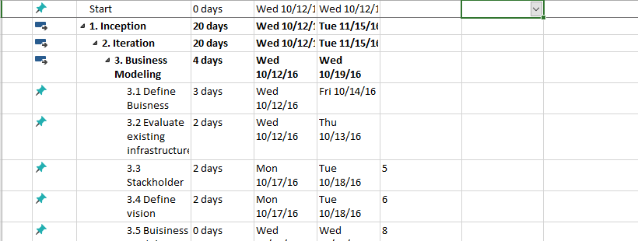

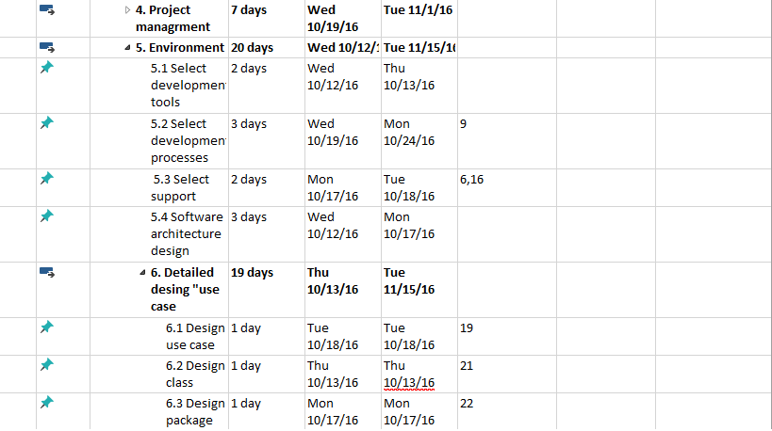

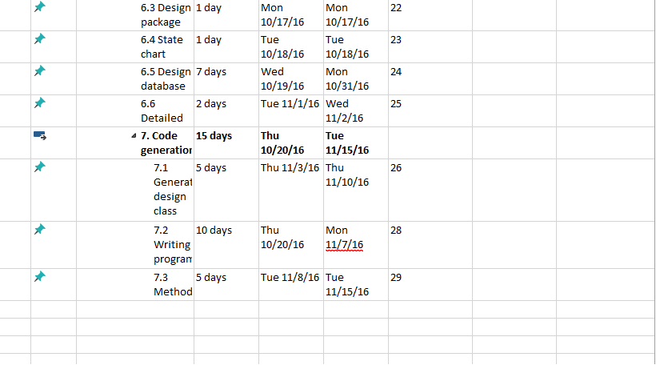

**1.3.6 Development environment**

**1.3.6.1 Development Tools and Support Services**

We are going to use android to develop the application for its vast number of supporting devices and the benefits which are listed below:

1. Android is open - Because it is Linux based open source so it can be developed by anyone
2. Easy access to the android app market – android owners are people who love mobile phones applications and with Google’s android app market you can download many applications for free.
3. Android has the largest installed base of all operating systems (OS) of any kind Android has been the best selling OS on tablets since 2013, and on Smartphone it is dominant by any metric.
4. Powerful development framework android gives you the everything to build a best in class app experience it also gives a single application model that lets you deploy the app broadly to millions of users across a wide range of devices .

**1.3.6.2 System Development Process**

We’re going to use the unified process to develop our application; the unified process divides the project into four phases as below:

* Inception
* Elaboration
* Construction
* Transition

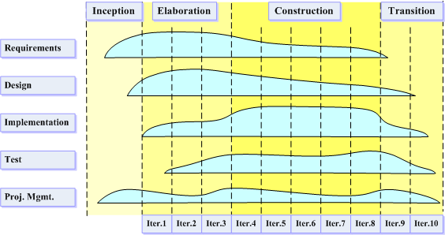

Figure (1) .Unified process life cycle model

**1.3.6.2.1 Inception Phase**

Inception is the smallest phase in the project, and ideally it should be quite short. If the Inception Phase is long then it may be an indication of excessive up-front specification, which is contrary to the spirit of the Unified Process.

The following are typical goals for the Inception phase.

* Establish a justification or business case for the project
* Establish the project scope and boundary conditions
* Outline the use cases and key requirements that will drive the design tradeoffs
* Outline one or more candidate architectures
* Identify risks
* Prepare a preliminary project schedule and cost estimate

**1.3.6.2.2 Elaboration Phase**

During the Elaboration phase the project team is expected to capture a healthy majority of the system requirements. However, the primary goals of Elaboration are to address known risk factors and to establish and validate the system architecture. Common processes undertaken in this phase include the creation of use case diagrams, conceptual diagrams (class diagrams with only basic notation) and package diagrams (architectural diagrams).

The architecture is validated primarily through the implementation of an Executable Architecture Baseline. This is a partial implementation of the system which includes the core most architecturally significant components. It is built in a series of small time boxed iterations. By the end of the Elaboration phase, the system architecture must have stabilized and the executable architecture baseline must demonstrate that the architecture will support the key system functionality and exhibit the right behavior in terms of performance, scalability, and cost.

**1.3.6.2.3 Construction Phase**

Construction is the largest phase in the project. In this phase the remainder of the system is built on the foundation laid in Elaboration. System features are implemented in a series of short, time boxed iterations. Each iteration results in an executable release of the software. It is customary to write full text use cases during the construction phase and each one becomes the start of a new iteration. Common Unified Modeling Language (UML) diagrams used during this phase include activity diagrams, sequence diagrams, collaboration diagrams, State Transition diagrams and interaction overview diagrams.

**1.3.6.2.4 Transition Phase**

The final project phase is Transition. In this phase the system is deployed to the target users. Feedback received from an initial release (or initial releases) may result in further refinements to be incorporated over the course of several Transition phase iterations. The Transition phase also includes system conversions and user training.